EXPERIMENT-7

IMPLEMENTATION OF HYBRID TOPOLOGY (BUS AND RING
TOPOLOGY) USING PACKET TRACER

Aim: To Implement a hybrid topology using packet tracer and hence to transmit
data between the devices connected using tree topology.
Software / Apparatus required: Packet Tracer / End devices, Hubs, connectors.
Steps for building topology:
Step 1: Start Packet Tracer
Step 2: Choosing Devices and Connections
Step 3: Building the Topology – Adding Hosts
Single click on the End Devices.
Single click on the Generic host.
Move the cursor into topology area.
Single click in the topology area and it copies the device.
Step 4: Building the Bus Topology – Connecting the Hosts to Hubs
Select a Hub, by clicking once on Hub and once on a generic Hub
Add the Hub by moving the plus sign “+”
Step 5: Building the Ring Topology – Connecting the Hosts to Hubs
Select a Hub, by clicking once on Hub and once on a generic Hub
Add the Hub by moving the plus sign “+”
Step 5: Connect PCs to Hub by first choosing Connections
Click once on the Automatic cable selector
Click once on PC2
Choose Fast Ethernet
Drag the cursor to Hub0
Click once on Hub0
Proceeding in this way create three Bus topologies
Step 6: Building the Tree Topology – Connecting the Hubs to Active Hub
Connect the hubs of star topologies to active hub to create tree topology.
Step 7: Configuring IP Addresses and Subnet Masks on the Hosts
To start communication between the hosts IP Addresses and Subnet Masks had to
be configured on the devices. Click once on PC0. Choose the Config tab and click
on FastEthernet0. Type the IP address in its field. Click on the subnet mask. It will
be Generated automatically.
Step 8: Verifying Connectivity in Realtime Mode
Be sure you are in Realtime mode.
Select the Add Simple PDU tool used to ping devices.
Click once on PC0, then once on PC3.
The PDU Last Status should show as Successful.
Step 9: Verifying Connectivity in Simulation Mode
Be sure you are in Simulation mode.
Deselect all filters (All/None) and select only ICMP.
Select the Add Simple PDU tool used to ping devices
Click once on PC0, then once on PC3.
Continue clicking Capture/Forward button until the ICMP ping is completed. The ICMP
messages move between the hosts, hub and switch. The PDU Last Status should show as Successful.
Output:
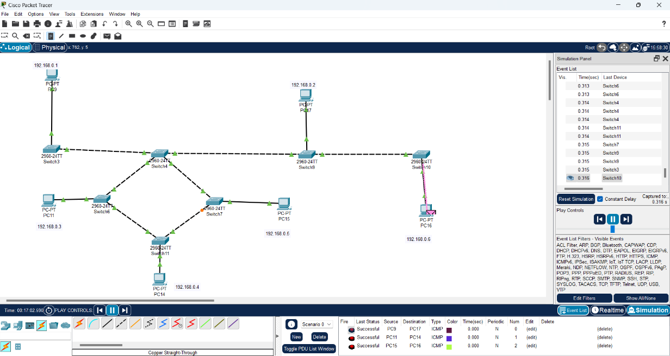

Result: Thus the Hybrid topology is implemented with Packet Tracer simulation Tool.

